ADVENTURE WORKS · TECHNICAL SUPPORT

Wheel Wobble, Out-of-True, or Loose Spokes
Wheels & Tires Document TS-009 Rev. A
Applies to | All Adventure Works models
Difficulty | Intermediate – Advanced
Time required | 30 – 60 minutes
Tools needed | Spoke wrench (correct nipple size), Truing stand or zip-tie pointer, Spoke tension meter (ideal)

Symptoms
- The rim moves side-to-side or up-and-down as the wheel spins.
- A rim brake rubs in one spot each revolution.
- A spoke 'pings' or feels loose when squeezed against its neighbor.
- A wobble that has grown worse after an impact.
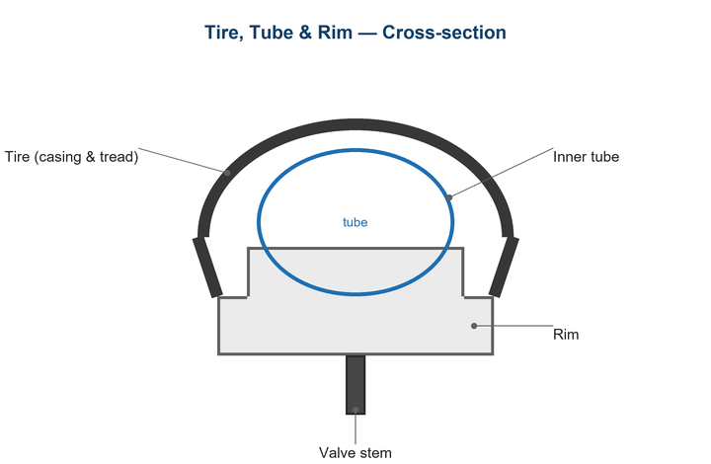
Figure 1. Even spoke tension keeps the rim laterally and radially true.

Likely Causes
- One or more spokes have lost tension.
- A spoke has loosened or broken after an impact.
- Uneven tension from the factory or a prior repair.
- A bent rim from a hard hit (pothole, curb, rock).
- A loose hub bearing letting the wheel rock.
Safety first
- A broken or very loose spoke can collapse a wheel — don't ride hard until fixed.
- Make small adjustments; over-tightening can crack the rim or pull the nipple through.
- Check that the wheel is dished correctly (centered) before final tensioning.

Customer Fix — Step by Step
Suitable for home repair with basic tools. Work through the steps in order.
- Spin the wheel and watch the rim against the brake pad or a fixed pointer to find the worst wobble.
- Squeeze pairs of spokes around the wheel to feel for any that are noticeably loose.
- To pull the rim toward one side at a wobble, tighten the spokes on the opposite side a quarter turn (and/or loosen the near side).
- Work in small quarter-turn steps and re-check after each, blending corrections over several spokes.
- If a spoke is broken, fit a replacement of the correct length and bring it up to match neighboring tension.
- Re-check brake clearance and that the wheel runs true before riding.

Technician Reference
Additional checks and adjustments for service technicians and advanced users.
- Mount the wheel in a truing stand; correct lateral true first, then radial (hop), then re-check lateral.
- Balance spoke tension with a tension meter; aim for even readings within the rim maker's range.
- Verify dish so the rim is centered between the locknuts.
- Stress-relieve the wheel (squeeze paired spokes) and re-true to settle the build.
- Inspect for a cracked rim, damaged nipple eyelets, or a bent hub flange and replace as needed.

Torque & Specifications
Setting | Specification
Adjustment step | ¼ turn at a time
Lateral true target | ≤0.5 mm
Radial (hop) target | ≤0.5 mm
Spoke tension | Per rim spec (often 100–120 kgf rear DS)
Dish | Rim centered between locknuts

Figure 2. Tighten opposite-side spokes to pull the rim back to center.
Pro tips
- If a spoke breaks far from home, partially unthread the spoke's nipple or tape the loose spoke and ride gently to safety.
- A drop of spoke-prep on threads keeps nipples from loosening over time.

When to Visit a Service Center
- The rim is cracked, dented, or won't true within range.
- Multiple spokes are broken or the wheel is badly buckled.
- Hub bearings are loose, notchy, or have play.
- You don't have a tension meter for a high-tension wheel build.
This guide is provided for reference. Torque values are typical starting points — always follow the specific component manufacturer's instructions. © Adventure Works.

